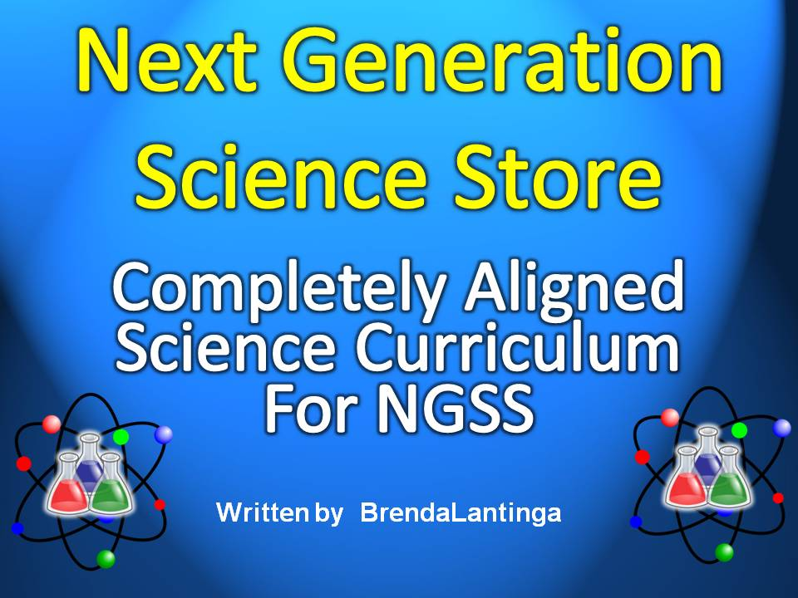**MS-ESS3-2. Analyze and interpret data on natural hazards to forecast future catastrophic events and inform the development of technologies to mitigate their effects.** [Clarification Statement: Emphasis is on how some natural hazards, such as volcanic eruptions and severe weather, are preceded by phenomena that allow for reliable predictions, but others, such as earthquakes, occur suddenly and with no notice, and thus are not yet predictable. Examples of natural hazards can be taken from interior processes (such as earthquakes and volcanic eruptions), surface processes (such as mass wasting and tsunamis), or severe weather events (such as hurricanes, tornadoes, and floods). Examples of data can include the locations, magnitudes, and frequencies of the natural hazards. Examples of technologies can be global (such as satellite systems to monitor hurricanes or forest fires) or local (such as building basements in tornado-prone regions or reservoirs to mitigate droughts).]

Guided Video Notes for:

<https://www.youtube.com/results?search_query=Volcanoes>

[NOVA SpaceNow 2015] Earth's Volcanoes - NEW Science Documentary

Name: _____________________________________________ Hour: _______ Grade: ________

<https://www.youtube.com/results?search_query=Volcanoes>

[NOVA SpaceNow 2015] Earth's Volcanoes - NEW Science Documentary

Play this song first: <https://www.youtube.com/watch?v=mIBTg7q9oNc>

1. What is the huge arc called that surrounds the Pacific Ocean? ________________________________________
2. ¾ of Earths volcanoes are situated here and _________% of all earthquakes also occur along this line.

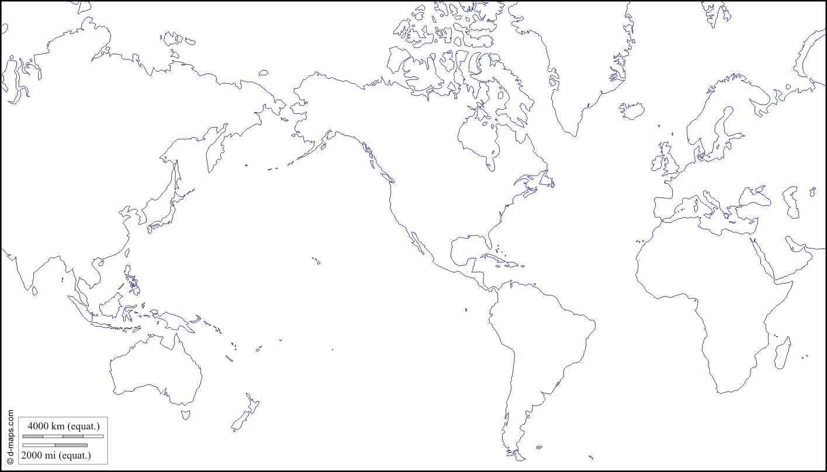

1. Shade in “The Ring of Fire” locations on the map above.
2. August __________ Indonesia, the Krakatoa volcano blew itself to pieces, creating the __________________ sound in recorded history.
3. June ____________ the Philippines Mount Pinatubo blasted debris _________________ into the atmosphere.
4. May ____________ Mount St. Helens caused _____________________ dollars of damage.
5. What percentage of volcanoes are situated in Alaska? ___________________
6. What do you think a volcanologist is? _________________________________________
7. Augustine is a __________________volcano the type of volcano found all around the Ring of Fire.
8. How are these volcanoes shaped? ____________________________________________
9. The lava is made up of blocks with different pieces to it so it’s called a: ______________________________________________________
10. What is the difference between Hawaii’s lava and Augustine’s lava? ________________________________________________________________________
11. What is it about silica that creates the different kinds of lava flows? ________________________________________________________________________
12. Why are thick lava flows more deadly? ________________________________________ ________________________________________________________________________
13. Why are these volcanoes more deadly? _______________________________________ ________________________________________________________________________
14. What does the horn blends show? ___________________________________________
15. What is created due to this? ________________________________________________
16. Mount Lassen in California is surrounded by: __________________________________ _______________________________________________________________________
17. All of this is driven by ______________ from deep underground.
18. What do the scientists look at closely? ________________________________________
19. What is surprising about the gasses? _________________________________________ _______________________________________________________________________
20. What is this the unique signature of? _________________________ called ________________
21. Where do these organisms live? ____________________________
22. As they grow they absorb ___________ into their ___________
23. When they dies the __________ to the _________________ forming layers of ____________________ and their carbon-12 is transferred to the __________________
24. What do scientists find interesting about this? __________________________________ ________________________________________________________________________
25. It’s like ________________ the sediments that are rich in phytoplankton down deep beneath these volcanoes to generate the ______________________________________

**15 Min. In**

1. Where is the water coming from? ________________________________________
2. The presence of jumbled oceanic rock _______________ from the sea is evidence that something __________________ is happening at the bottom of the _______________.
3. Geologists know that only an enormous process called ______________________ could shift the mixed ocean sediment to a new location.
4. How does the seawater get deep underground? _______________________________ ______________________________________________________________________
5. This process is the ____________________ that powers the ring of fire killer volcanoes, but deep underground the Ring of Fire hides another even more _______________ secret ____________________ that can destroy entire cities.
6. _________% of the worlds earthquakes occur in this narrow band around the _________________________________.
7. What explains the preserved beach that is no longer on the beach? ________________ _______________________________________________________________________
8. Which had to be the result of a _____________________________________________
9. What magnitude was the Anchorage earthquake? _______________________

**25 Min. In**

1. What term is used to describe the earthquake? _________________________________
2. Earthquakes can generate killer waves called ______________________________
3. What does a seismic station monitor? ________________________________________
4. What can be done as a result of collecting data? ________________________________
5. Alaska has about ______________ earthquakes every month
6. What kind of pattern do the earthquakes occur in? ______________________________ ________________________________________________________________________
7. The earthquake _________________ exactly follow the path taken by the seafloor as it moves down underneath the _______________________. Earthquakes are triggered as the rocks _________________________ each other down into the Earth.
8. Why is making a map of the seafloor very helpful? ______________________________ _______________________________________________________________________
9. What is a subduction trench? _______________________________________________
10. What are the deep trenches located? _________________________________________
11. How many plates cover the planet? _________________
12. What is located high up on the mountain? _____________________________________
13. How many are located across the U.S.? _______________________________________
14. What can they see when all of the data is combined? ____________________________ _______________________________________________________________________
15. What does the mantle have to do with this motion? _____________________________ ________________________________________________________________________
16. If the convection currents are dragging the seafloor under another plate, why hasn’t the ocean disappeared? ____________________________________________________
17. What is a “black smoker”? __________________________________________________
18. What is the mid-ocean ridge? _______________________________________________ _______________________________________________________________________
19. Will the map of Earth stay the same, or change continuously? _____________________